



*NCJET*

“Compete With The Elite”

YOUTH SCRATCH SPORT TOURNAMENT

# JR GOLD EVENT

**April 23, 2017**

AT

Strikes Unlimited, 5681 Lonetree Blvd.,

Rocklin, CA 95765 - (916) 626-3600

# $2 Brackets

4 games of Qualifying on

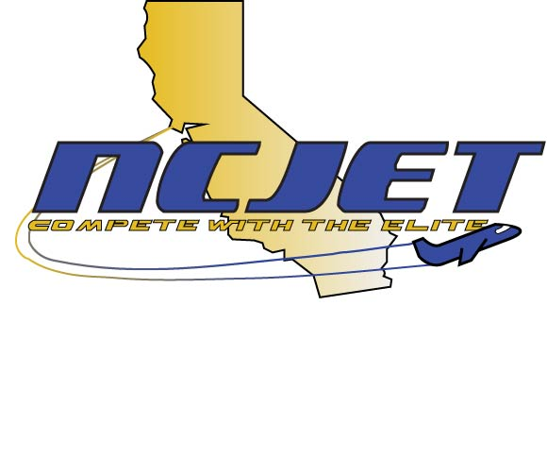Sport Pattern

Boys 190/up, 189/under

Girls 180/up, 179/under

Pinfall carries over

to match play

Top 3 Finalists bowl a stepladder

Sunday Check in at 9:00 a.m. – Start at 10:00 a.m.

ENTRY FEES $30.00 lineage est.*

$ 5.00 NCJET membership

$15.00 prize fund

$50.00 Entry Fee

USBC Certified - Tournament Directors:

 Debbie Haggerty (916) 663-5897 – [Debra.haggerty7@gmail.com](mailto:Debra.haggerty7@gmail.com)

Welby Spanton (916) 346-5917 – welby18@gmail.com